**Office 360 Excel & Power Pivot Installation Guide**

As the business intelligence space leader, Microsoft is continuously upgrading Power Pivot every month. So, do not be surprised if your screen is slightly different from the images in this document.

**Instructions to download Excel from Microsoft Office 365**

* Go to https://www.office.com/ & sign in using your NEIT credentials.

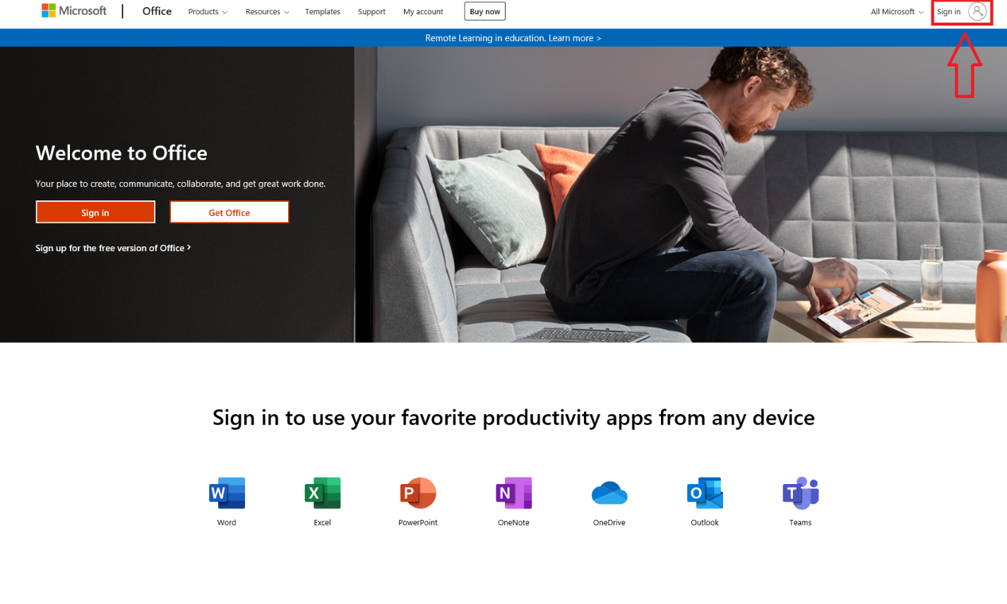

* Under the home tab, select “Install Office”.

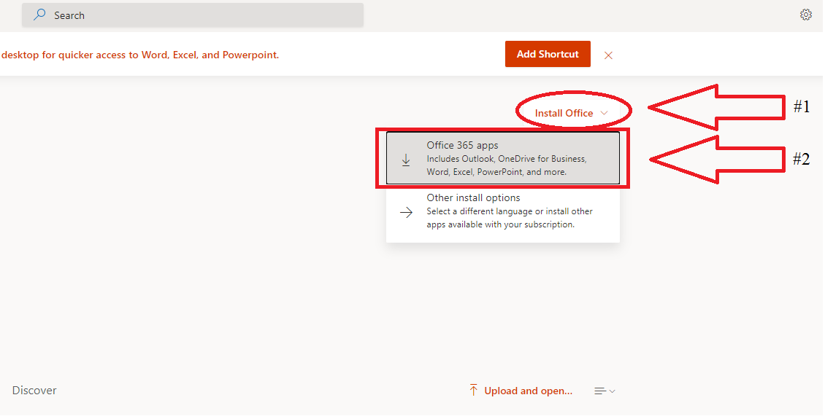

* Launch the downloaded executable and follow the installation guide.

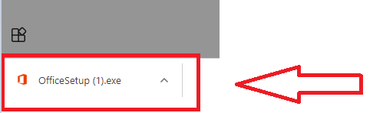

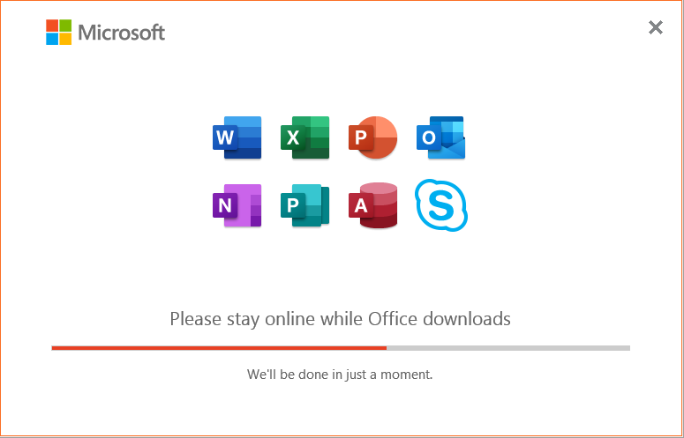

**Instructions to enable Power Pivot features in Excel**

* Launch Excel (via taskbar or start menu).
* Select “File” at the top-left navigation pane.

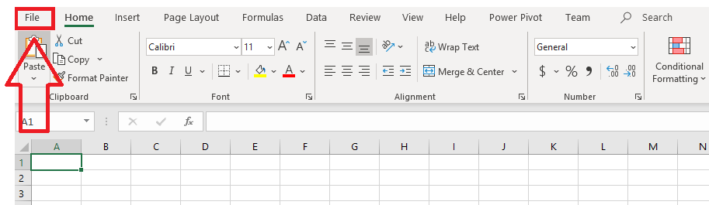

* Select the “Options” button, located on the left-side panel.

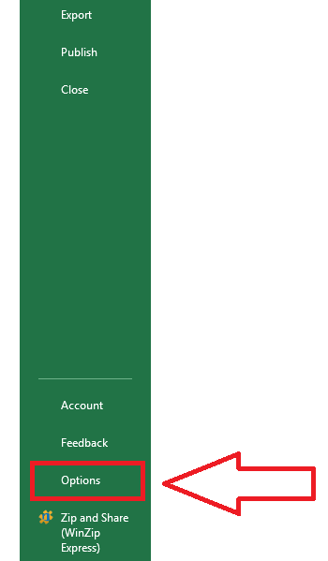

* Select the “Add-ins” tab (#1), select the drop-down arrow for the “Manage” field (#2), click “COM Add-ins” (#3), then press “Go…” (#4). Please refer to the image below for assistance.

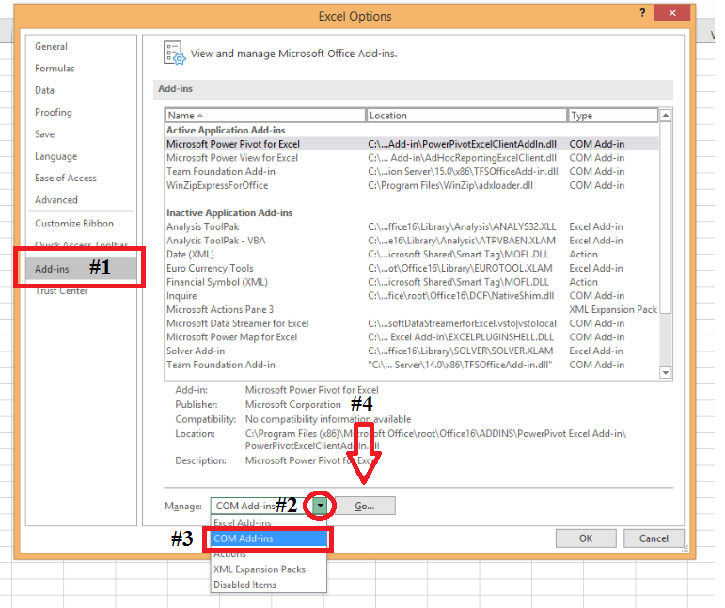

* Ensure that the following Add-ins are selected:
  + *Microsoft Power Pivot for Excel*
  + *Microsoft Power View for Excel*
* Afterwards, press “OK”.

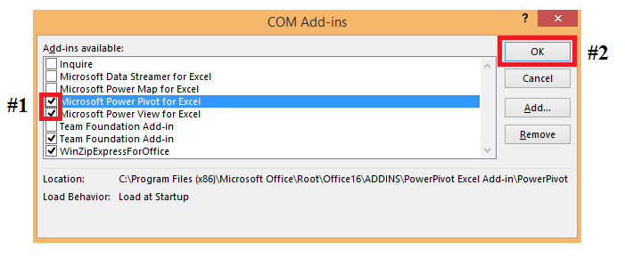

* Now, the “Power Pivot” tab should be visible and accessible in Excel.

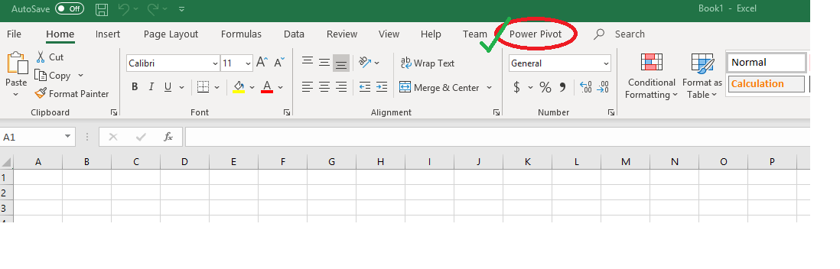

* ***Last step:*** Click on the “Power Pivot” tab, take a Snippet, and submit the PNG file proving that you have access to Power Pivot tools. Your graphical snapshot should be similar to the image below.

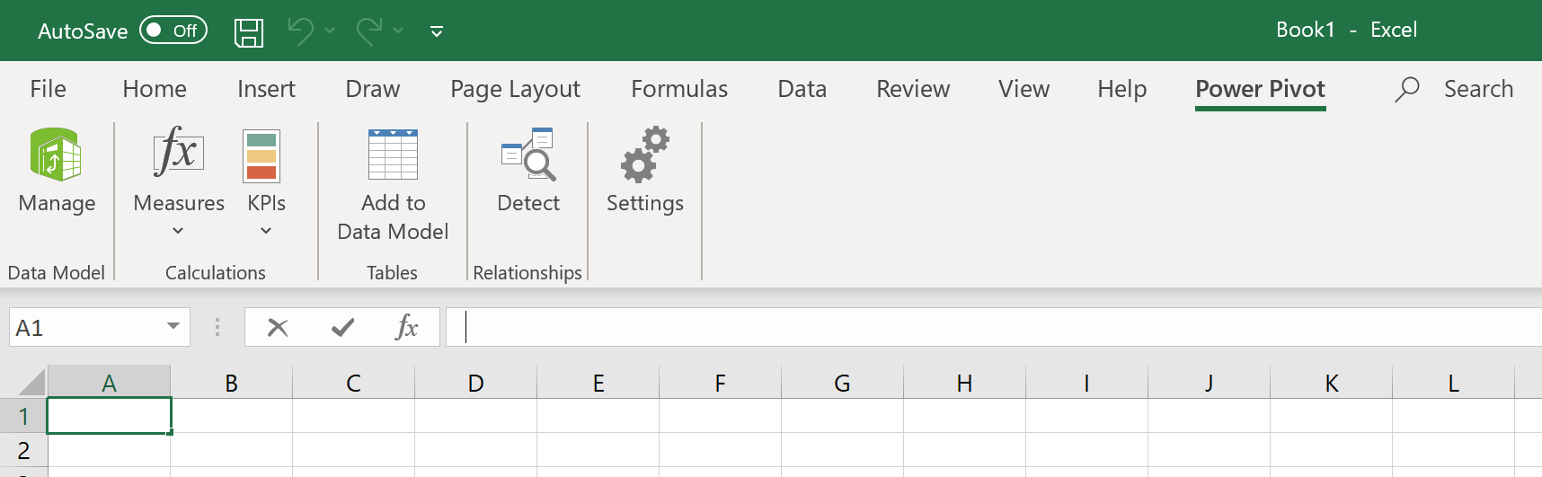

Alternatively, for some reason(s), if you have no Office 360 access at home, log in to NEIT vLabs and complete the exercise using one of the machines in N210, N215, or N110. You do not have to install Office 360, or Excel, or Power Pivot because this is already done for you by DOTS (Department of Technical Services). Just do the last step in this exercise to indicate that you know how to invoke Power Pivot from within Excel.